https://fsd.tcsbank.ru/case/4507545/info
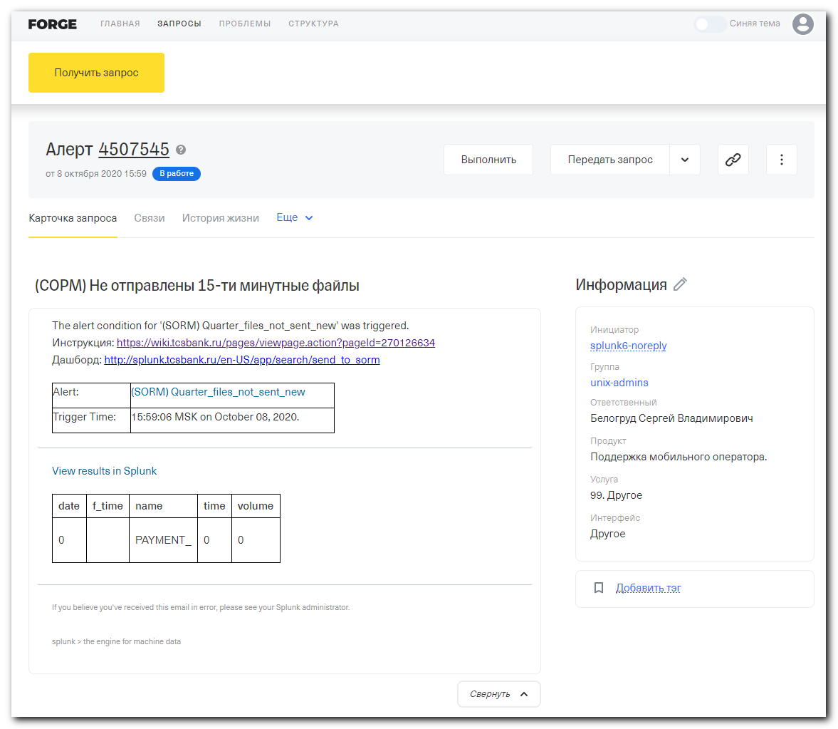
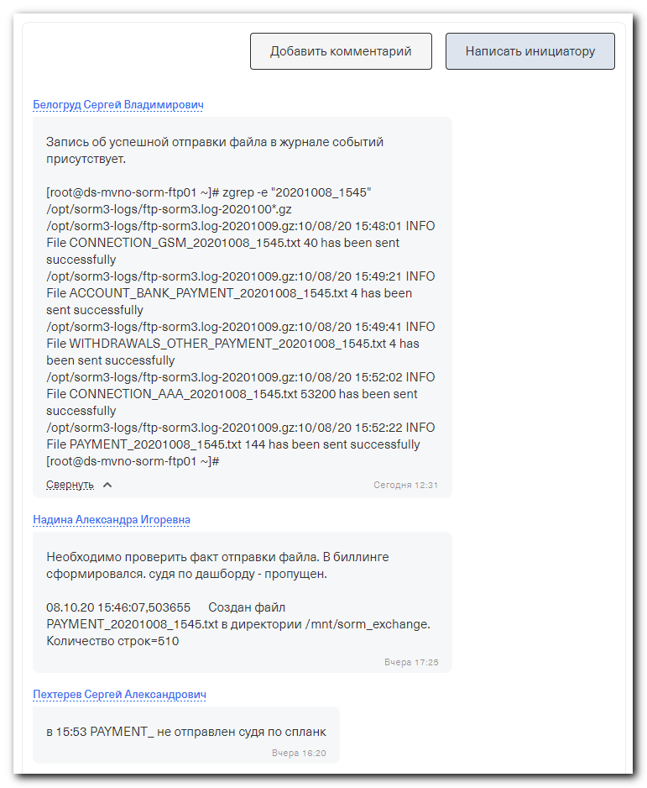

(SORM3) Проблемы при отправке файлов
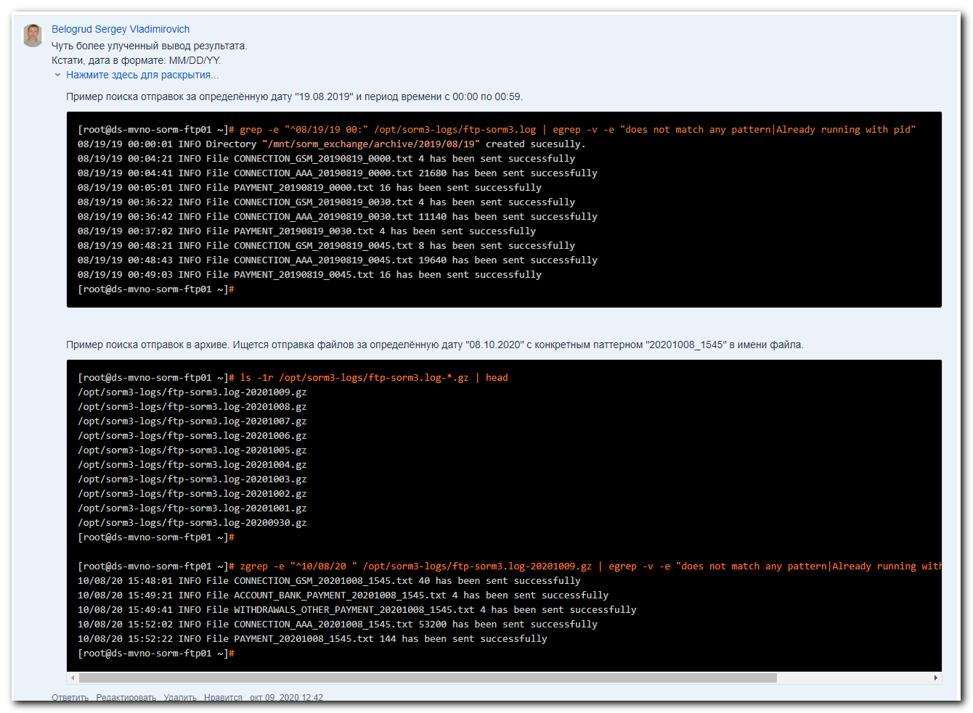

Belogrud Sergey Vladimirovich
Чуть более улученный вывод результата.
Кстати, дата в формате: ММ/DD/YY.

Нажмите здесь для раскрытия...
Пример поиска отправок за определённую дату "19.08.2019" и период времени с 00:00 по 00:59.

[root@ds-mvno-sorm-ftp01 ~]# grep -e "^08/19/19 00:" /opt/sorm3-logs/ftp-sorm3.log | egrep -v -e "does not match any pattern|Already running with pid"
08/19/19 00:00:01 INFO Directory "/mnt/sorm_exchange/archive/2019/08/19" created sucesully.
08/19/19 00:04:21 INFO File CONNECTION_GSM_20190819_0000.txt 4 has been sent successfully
08/19/19 00:04:41 INFO File CONNECTION_AAA_20190819_0000.txt 21680 has been sent successfully
08/19/19 00:05:01 INFO File PAYMENT_20190819_0000.txt 16 has been sent successfully
08/19/19 00:36:22 INFO File CONNECTION_GSM_20190819_0030.txt 4 has been sent successfully
08/19/19 00:36:42 INFO File CONNECTION_AAA_20190819_0030.txt 11140 has been sent successfully
08/19/19 00:37:02 INFO File PAYMENT_20190819_0030.txt 4 has been sent successfully
08/19/19 00:48:21 INFO File CONNECTION_GSM_20190819_0045.txt 8 has been sent successfully
08/19/19 00:48:43 INFO File CONNECTION_AAA_20190819_0045.txt 19640 has been sent successfully
08/19/19 00:49:03 INFO File PAYMENT_20190819_0045.txt 16 has been sent successfully
[root@ds-mvno-sorm-ftp01 ~]#

Пример поиска отправок в архиве. Ищется отправка файлов за определённую дату "08.10.2020" с конкретным паттерном "20201008_1545" в имени файла.

[root@ds-mvno-sorm-ftp01 ~]# ls -1r /opt/sorm3-logs/ftp-sorm3.log-*.gz | head
/opt/sorm3-logs/ftp-sorm3.log-20201009.gz
/opt/sorm3-logs/ftp-sorm3.log-20201008.gz
/opt/sorm3-logs/ftp-sorm3.log-20201007.gz
/opt/sorm3-logs/ftp-sorm3.log-20201006.gz
/opt/sorm3-logs/ftp-sorm3.log-20201005.gz
/opt/sorm3-logs/ftp-sorm3.log-20201004.gz
/opt/sorm3-logs/ftp-sorm3.log-20201003.gz
/opt/sorm3-logs/ftp-sorm3.log-20201002.gz
/opt/sorm3-logs/ftp-sorm3.log-20201001.gz
/opt/sorm3-logs/ftp-sorm3.log-20200930.gz
[root@ds-mvno-sorm-ftp01 ~]#

[root@ds-mvno-sorm-ftp01 ~]# zgrep -e "^10/08/20 " /opt/sorm3-logs/ftp-sorm3.log-20201009.gz | egrep -v -e "does not match any pattern|Already running with pid" | egrep -e "20201008_1545"
10/08/20 15:48:01 INFO File CONNECTION_GSM_20201008_1545.txt 40 has been sent successfully
10/08/20 15:49:21 INFO File ACCOUNT_BANK_PAYMENT_20201008_1545.txt 4 has been sent successfully
10/08/20 15:49:41 INFO File WITHDRAWALS_OTHER_PAYMENT_20201008_1545.txt 4 has been sent successfully
10/08/20 15:52:02 INFO File CONNECTION_AAA_20201008_1545.txt 53200 has been sent successfully
10/08/20 15:52:22 INFO File PAYMENT_20201008_1545.txt 144 has been sent successfully
[root@ds-mvno-sorm-ftp01 ~]#

